DevOps Platform POC Documentation

1. Executive Summary
This Proof of Concept (POC) demonstrates the design and implementation of an end-to-end DevOps platform that automates infrastructure provisioning, configuration management, continuous integration, code quality analysis, artifact management, and containerization. The objective of this POC is to showcase real-world DevOps practices aligned with enterprise standards.

2. Objectives of the POC
- Automate infrastructure provisioning using Infrastructure as Code (IaC)
- Ensure consistent server configuration using Configuration Management
- Implement a complete CI/CD pipeline
- Integrate code quality checks and artifact management
- Build and push Docker images automatically
- Follow best practices such as role isolation, security, and scalability

3. High-Level Architecture

3.1 Tools & Technologies Used
- Cloud Provider: AWS EC2
- IaC: Terraform
- Configuration Management: Ansible
- CI/CD Tool: Jenkins
- Build Tool: Maven
- Code Quality: SonarQube (Dockerized)
- Artifact Repository: Nexus (Dockerized)
- Containerization: Docker
- Container Registry: DockerHub

4. Infrastructure Design

4.1 Server Segregation Strategy
Each major component runs on a dedicated EC2 instance to ensure: - Fault isolation - Better security - Independent scalability
Server | Purpose
Jenkins Server | CI/CD Orchestration
SonarQube Server | Code Quality Analysis
Nexus Server | Artifact Repository
Docker Host | Docker Image Build & Push
Ansible Control Node | Configuration Management

5. Infrastructure Provisioning (Terraform)

5.1 Terraform Responsibilities
- Provision EC2 instances
- Attach required security groups
- Configure key pairs
- Output public IPs for Ansible inventory

5.2 Terraform Best Practices Used
- Modular resource definitions
- Idempotent execution
- Outputs used for dynamic inventory

6. Step-by-Step POC Execution with Screenshot Guidance
This section explains the complete POC execution in the exact sequence followed, along with where screenshots should be captured for POC submission.

Step 1: Infrastructure as Code – Terraform

1.1 Terraform Project Structure
Terraform code is organized in a clean and modular directory structure to improve readability and maintainability.
Terraform project directory structure:
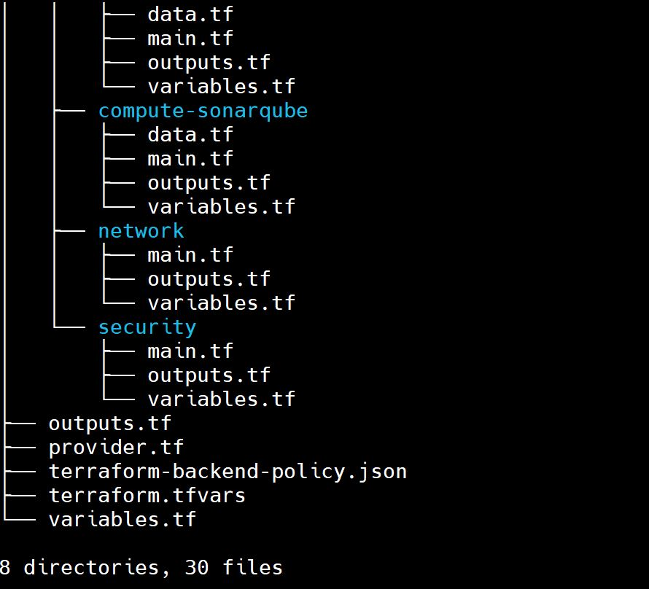
main.tf
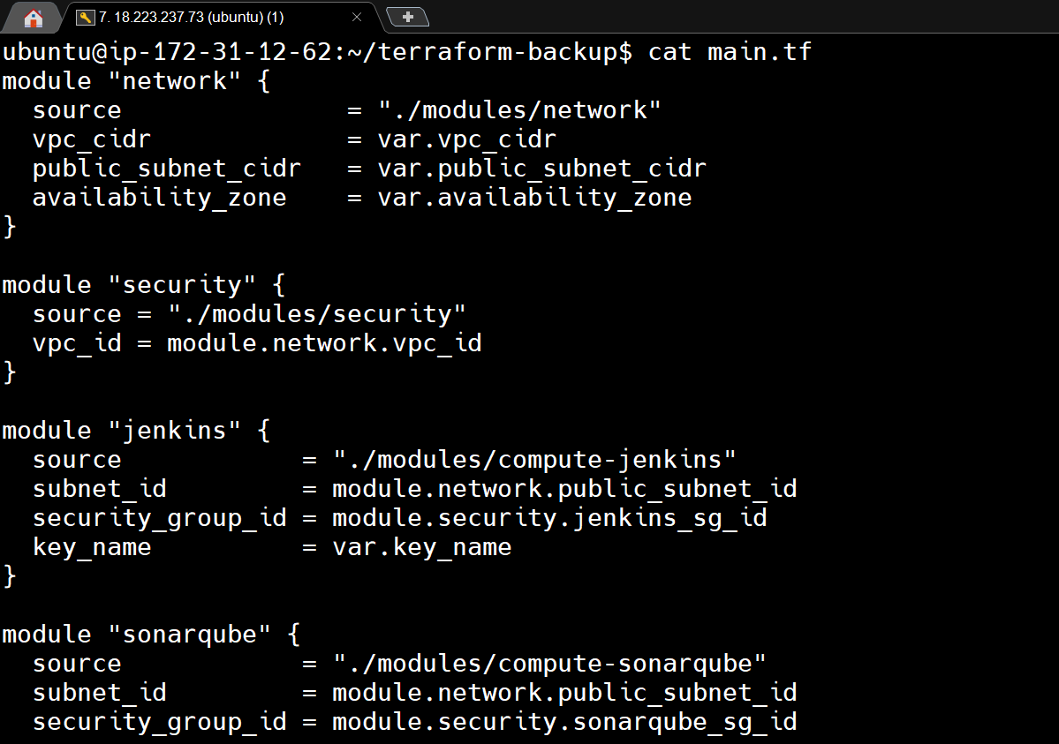
variables.tf
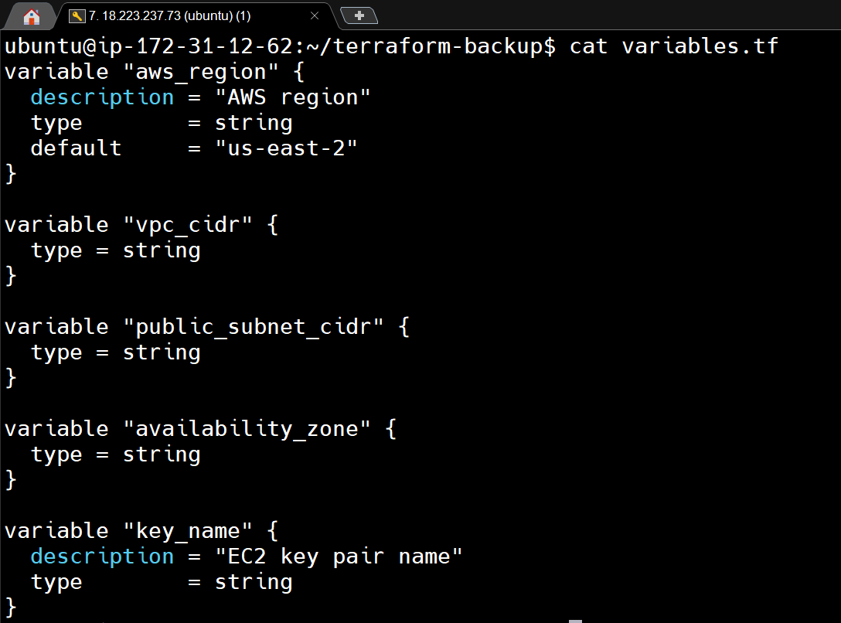
outputs.tf
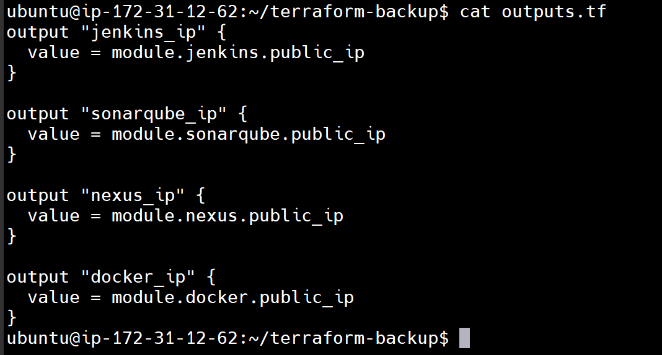

1.2 Terraform Execution Workflow
Terraform is executed in the following order:
- terraform init
  - Initializes provider plugins and backend
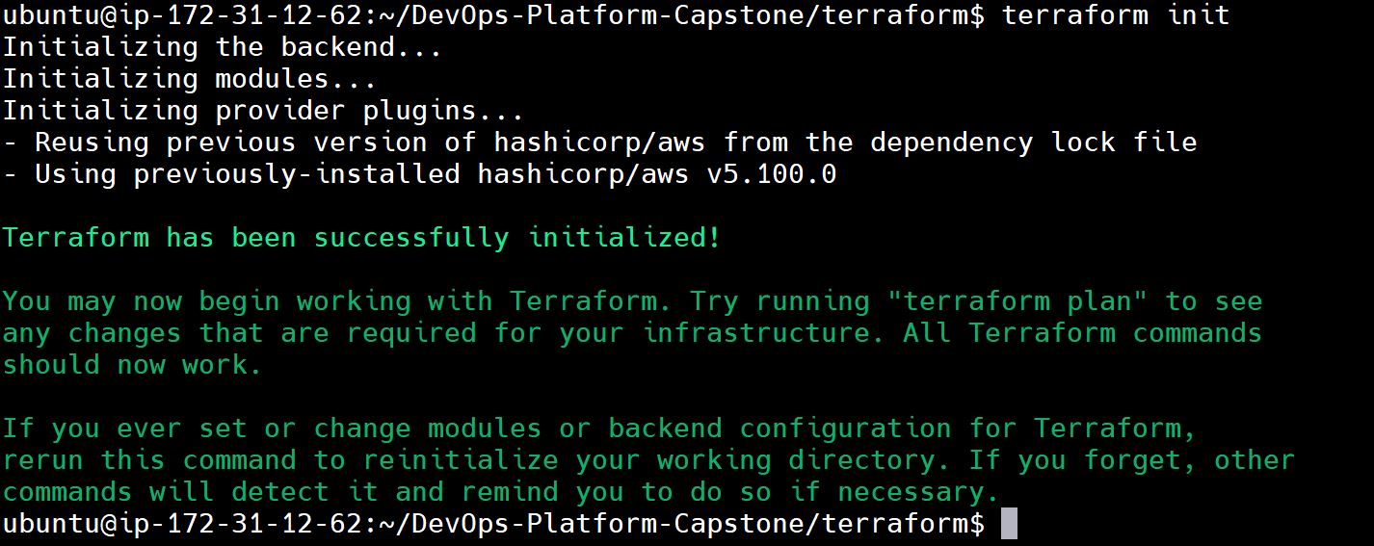
- terraform plan
  - Shows execution plan before applying changes
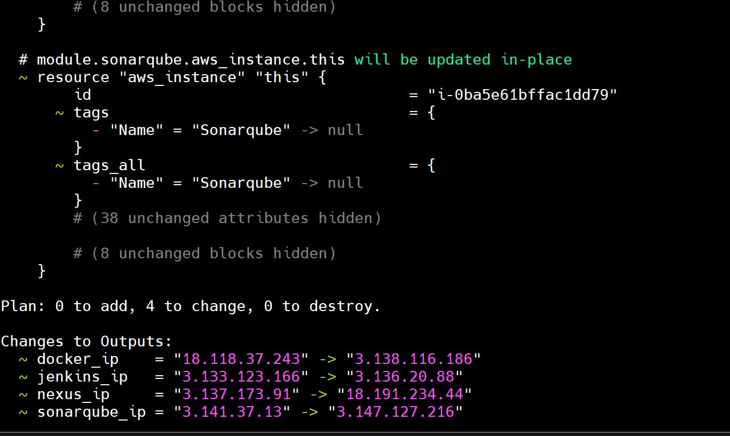
- terraform apply
  - Provisions EC2 instances
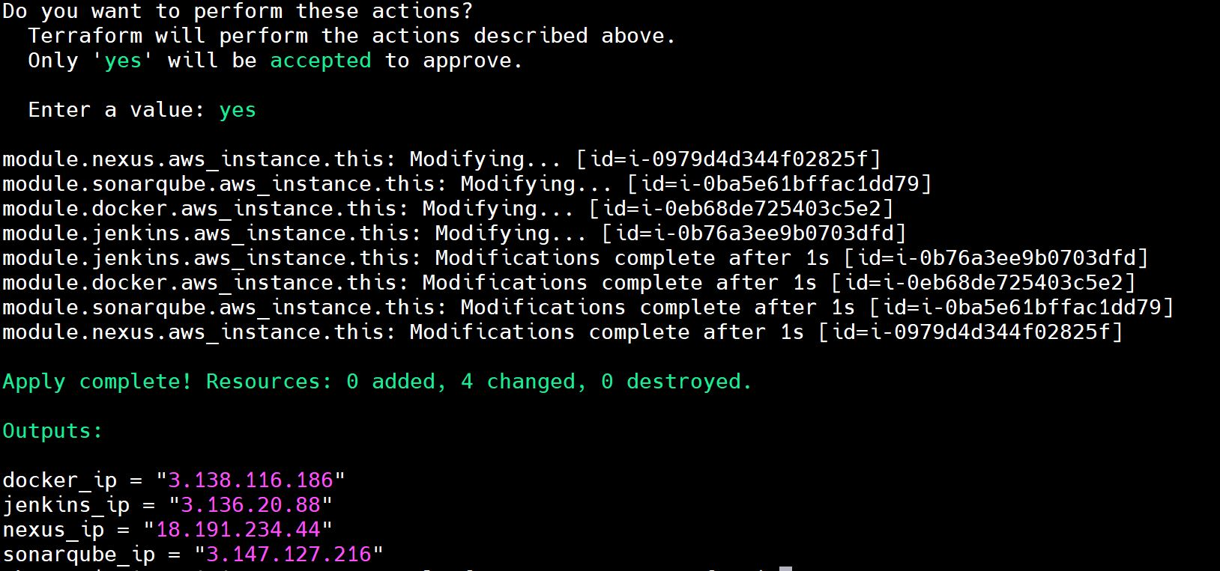

Step 2: Configuration Management – Ansible

2.1 Ansible Directory Structure
Ansible is structured using roles for clarity and scalability.
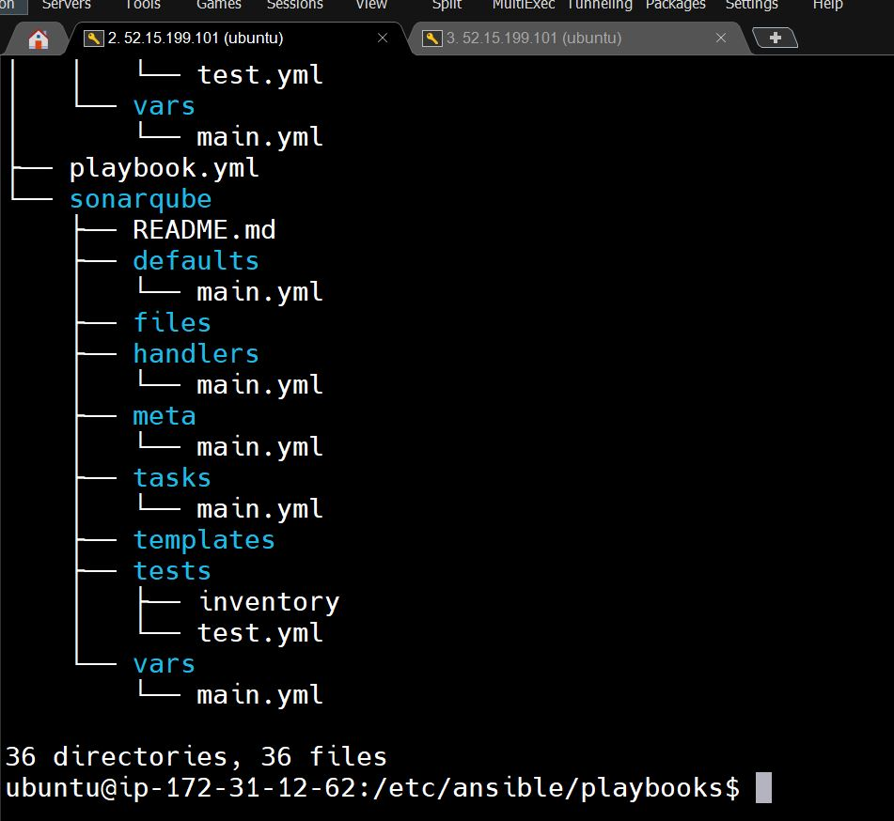
Inventory configuration (dynamic AWS inventory)
Ansible dynamic inventory is used to automatically fetch and update the list of AWS EC2 instances in real time instead of maintaining static IPs or hostnames.
Dynamic inventory keeps Ansible in sync with constantly changing AWS infrastructure.
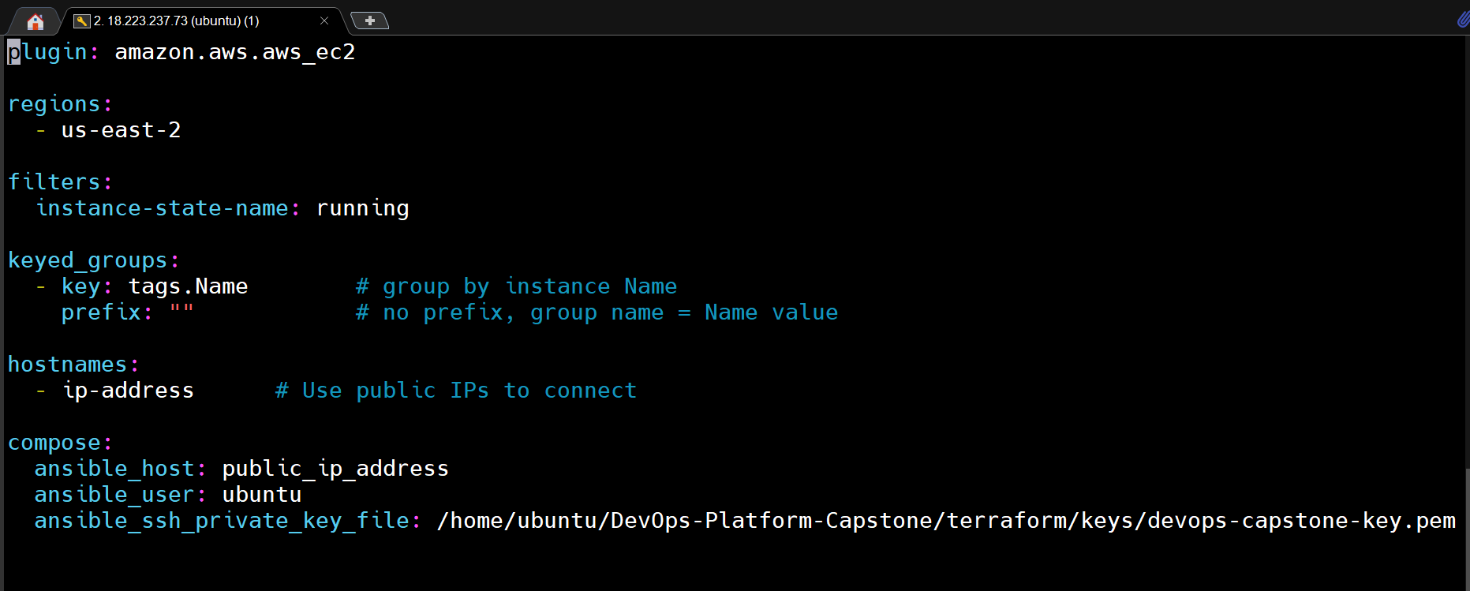
Role-based structure - Separation of responsibilities
Ansible role-based structure is used to organize automation into reusable, modular components, where each role handles a specific responsibility (e.g., Jenkins, Docker, Nginx).
Roles help structure Ansible code cleanly by separating tasks based on responsibility.
Why we use it:
- Clear separation of responsibilities
- Improves readability and maintainability
- Encourages reusability across projects
- Makes large playbooks easier to manage and scale
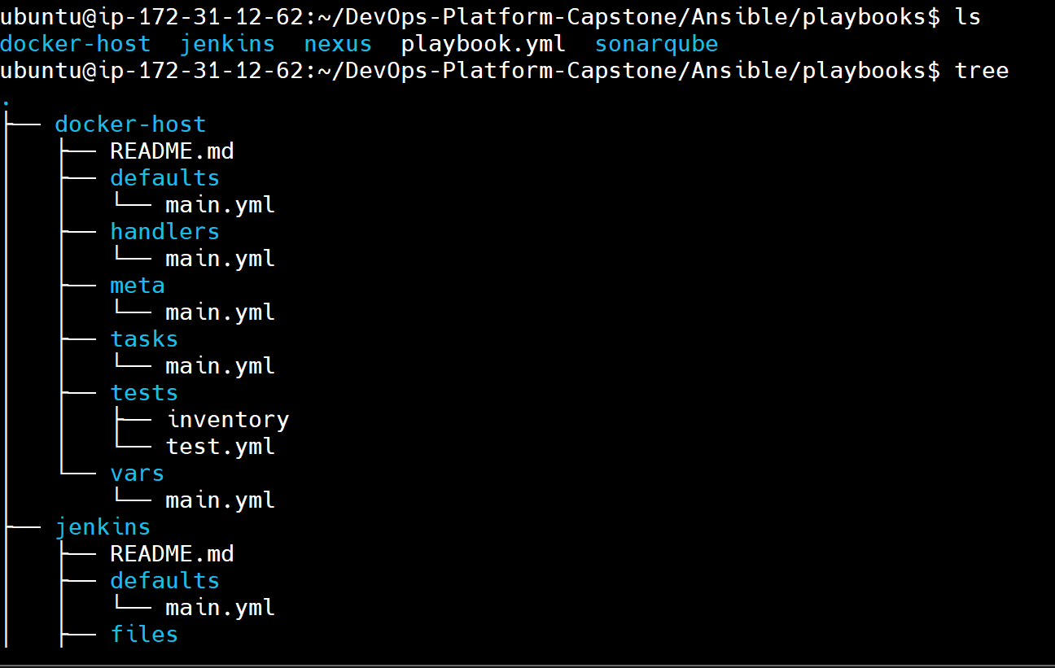
Explain: - Inventory configuration (dynamic AWS inventory) - Role-based structure - Separation of responsibilities
- Main playbook file
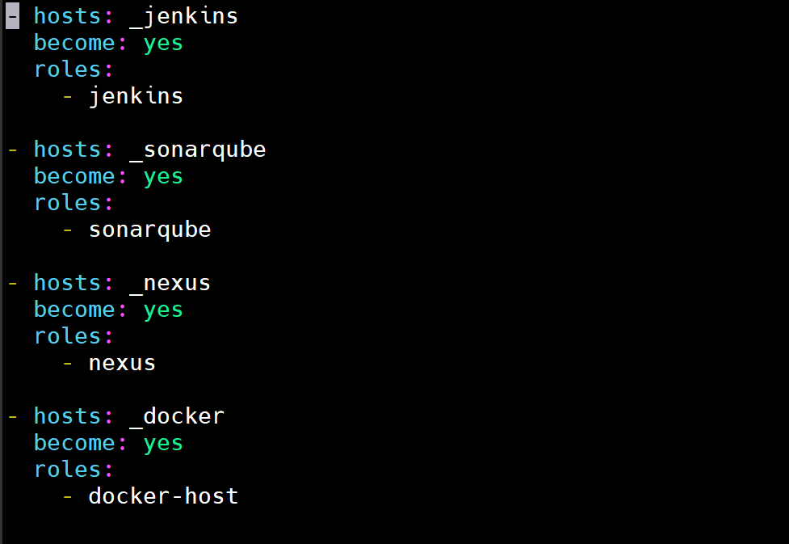

2.2 Individual Ansible Roles Execution
Each role targets a specific server: - Jenkins role → Jenkins server - SonarQube role → SonarQube server - Nexus role → Nexus server - Docker-host role → Docker build server
Explain: - How Ansible identifies servers using inventory - Role-to-host mapping
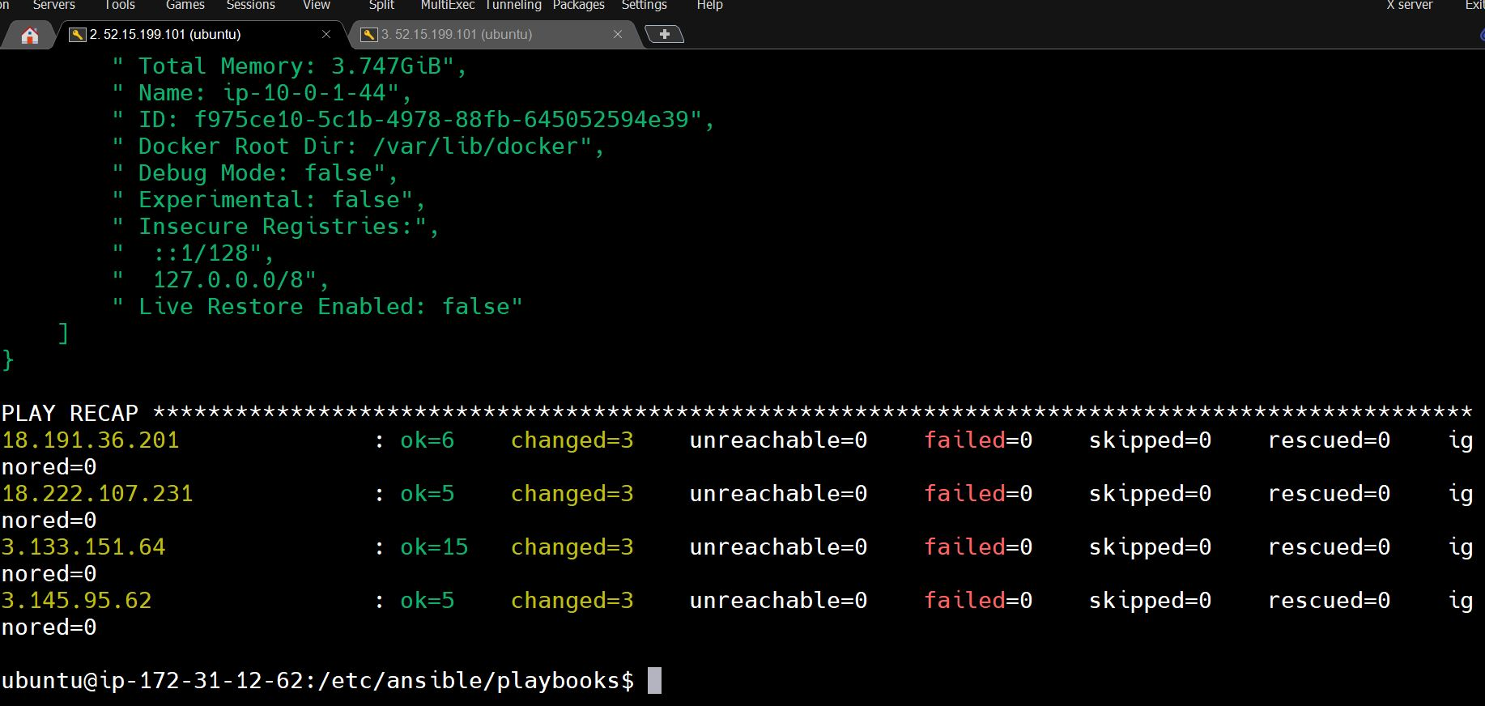

2.3 Post-Ansible Verification
After playbook execution, servers are verified manually:
- Jenkins service status
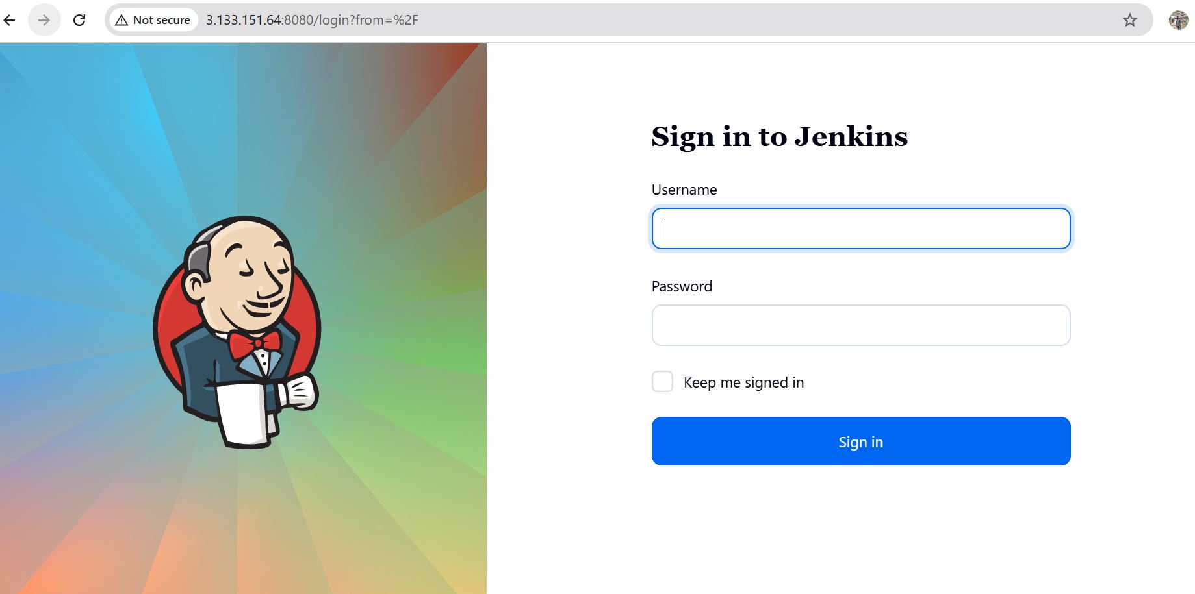
- Jenkins plugins automatically installed
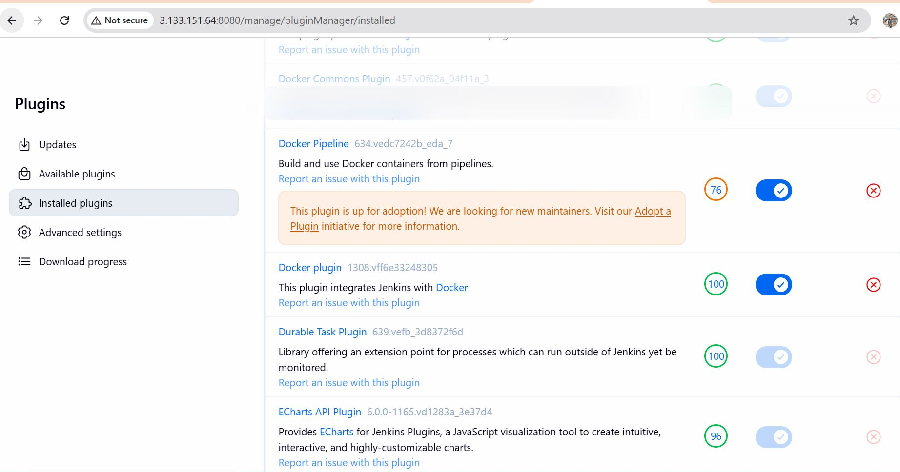
- SonarQube container running
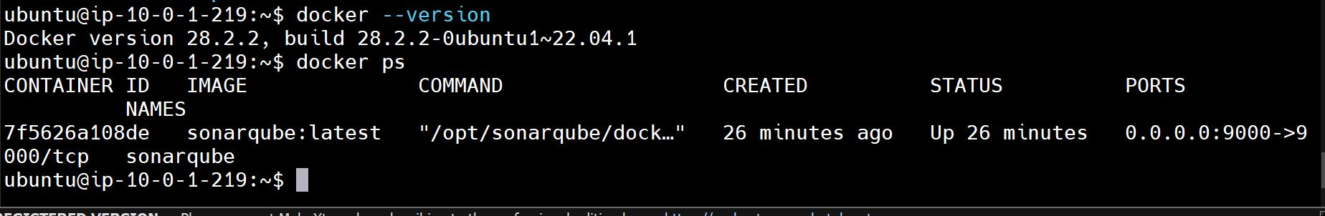
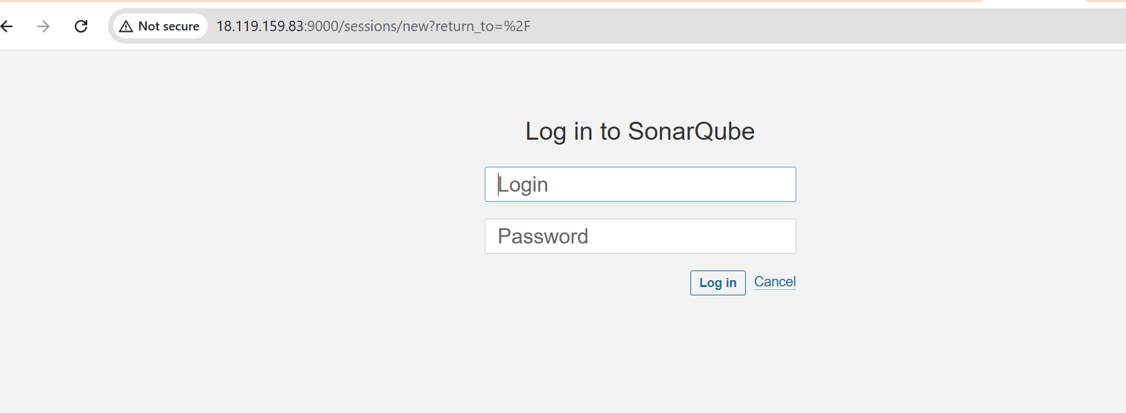
- Nexus container running
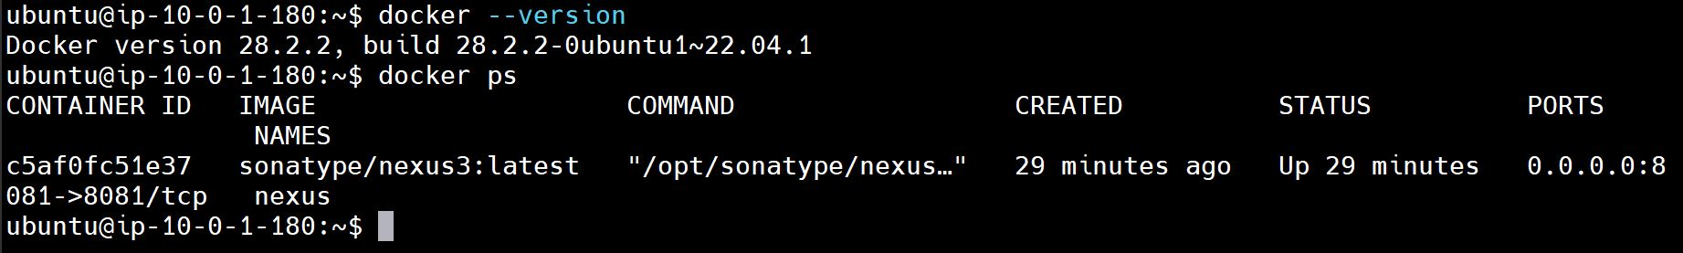
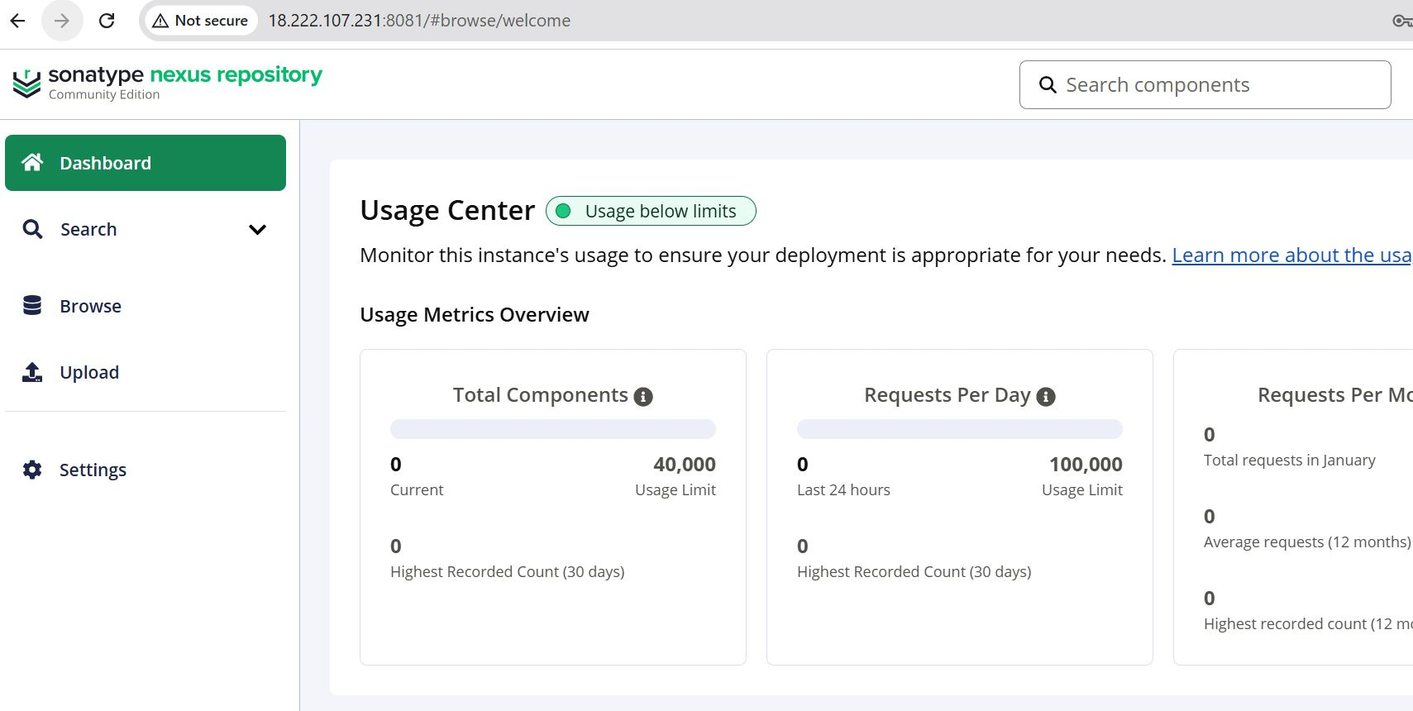
- Docker installed and running
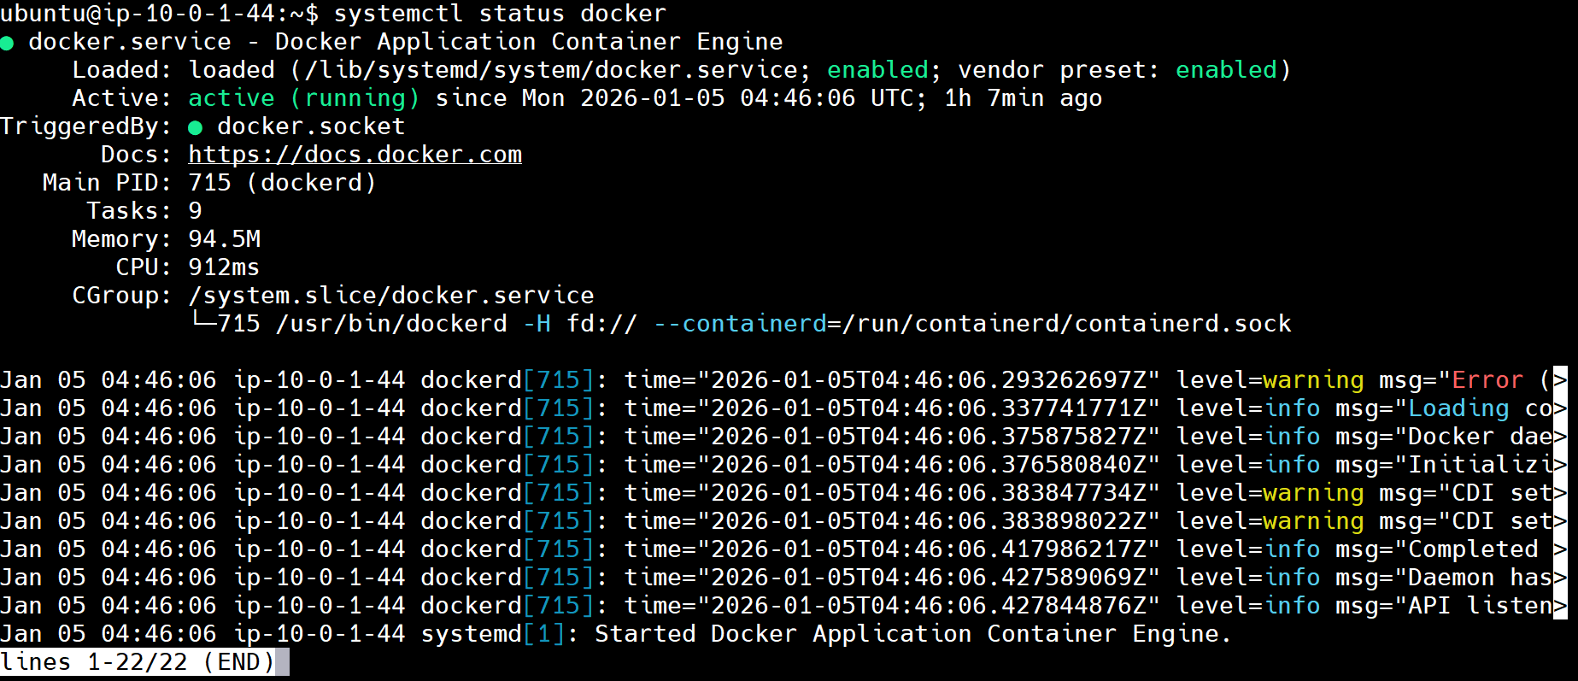

Step 3: Jenkins Configuration & CI/CD Pipeline

3.1 Jenkins GUI Setup
Explain: - Initial Jenkins access:
Plugin installation
- Global tool configuration (JDK, Maven)
- Credentials configuration (DockerHub, Sonar, Nexus)
- Add SonarQube server details in manage Jenkins --> System

3.2 Jenkins Pipeline Configuration
Pipeline includes stages: 1. Code checkout 2. Maven build 3. SonarQube analysis 4. Artifact upload to Nexus 5. Docker image build 6. Docker image push
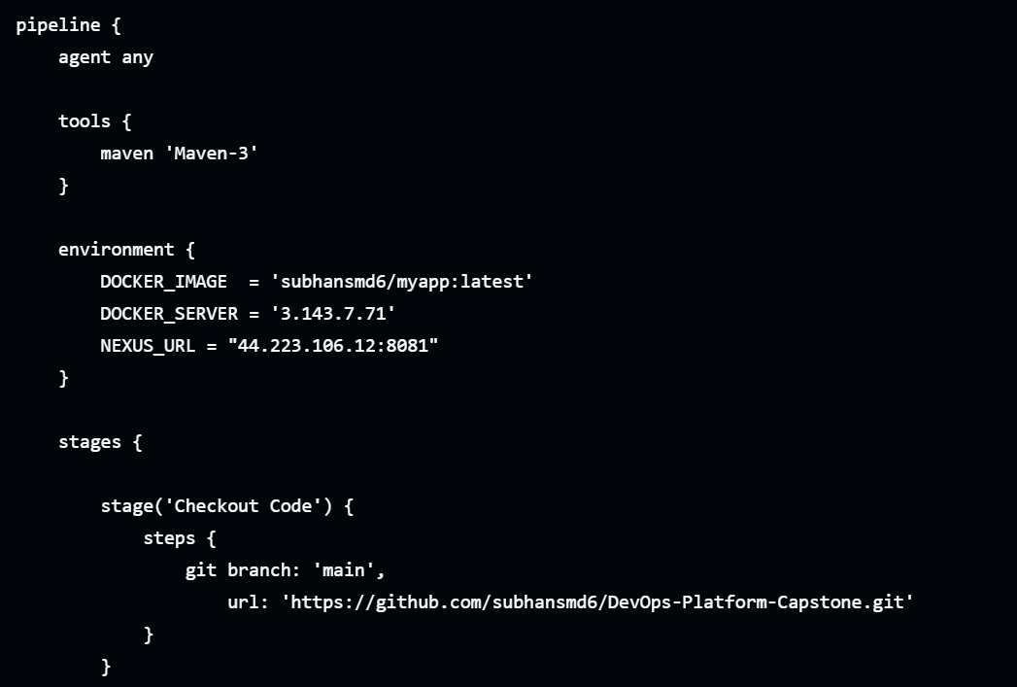

3.3 Jenkins Pipeline Execution
Pipeline is triggered manually or automatically.
We can also setup build triggers like Webhook triggers or Poll SCM to automate the process of Jenkins CI/CD pipeline.
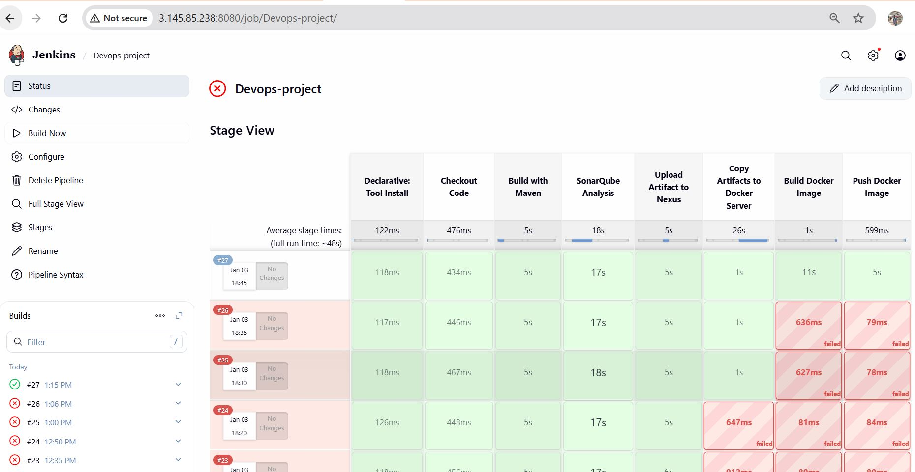

Step 4: SonarQube Verification
Explain: - SonarQube project creation - Quality gate status
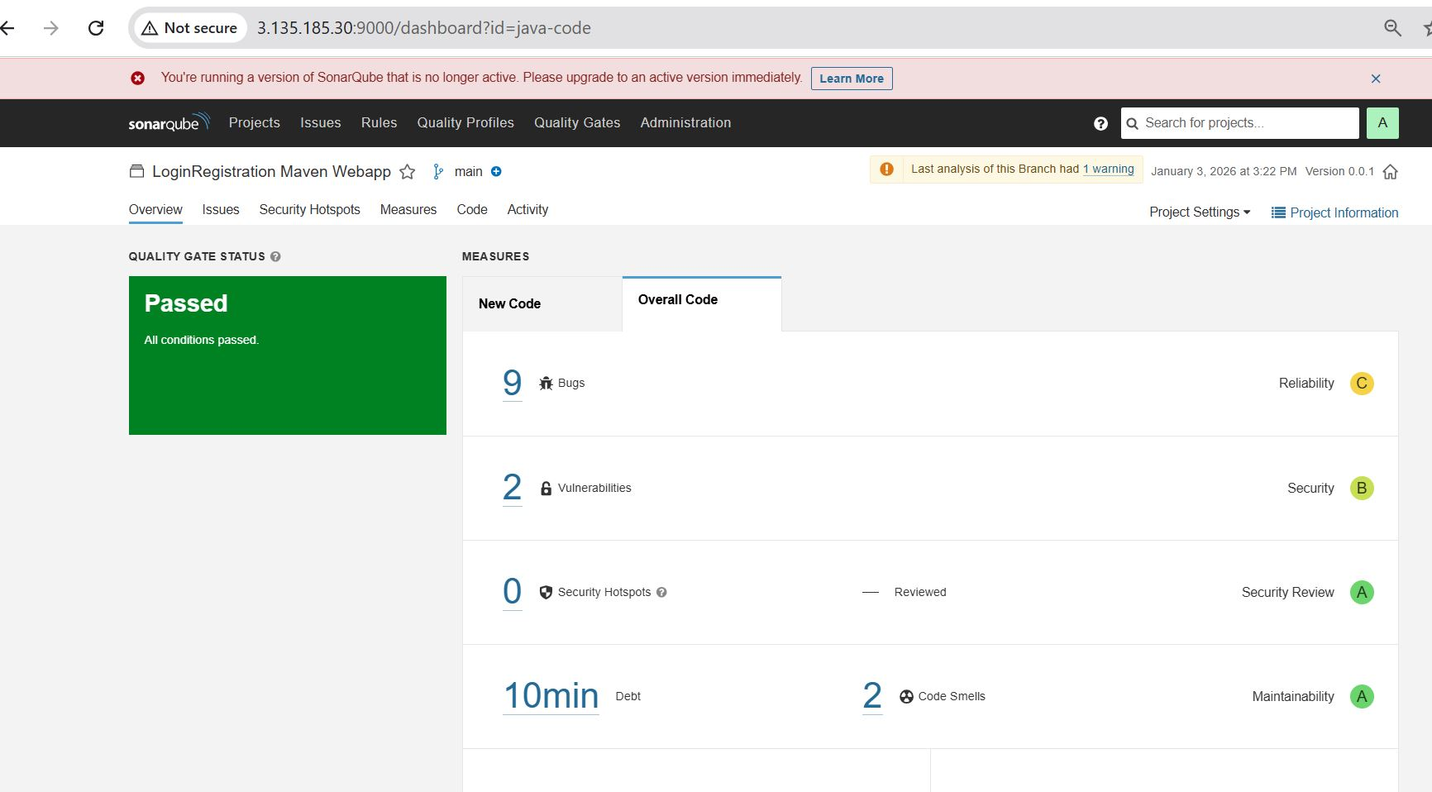

Step 5: Nexus Verification
Explain: - Repository configuration - Uploaded artifacts
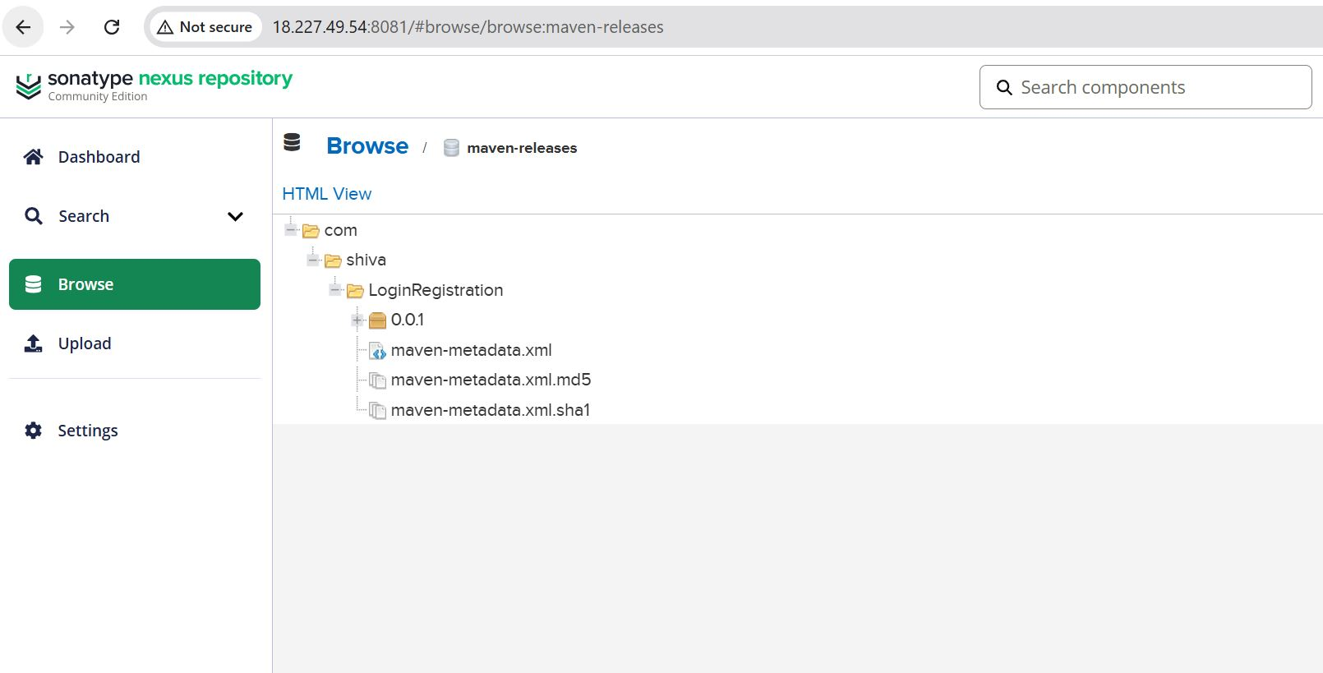

Step 6: DockerHub Verification
Explain: - Docker image tagging - Image push via Jenkins
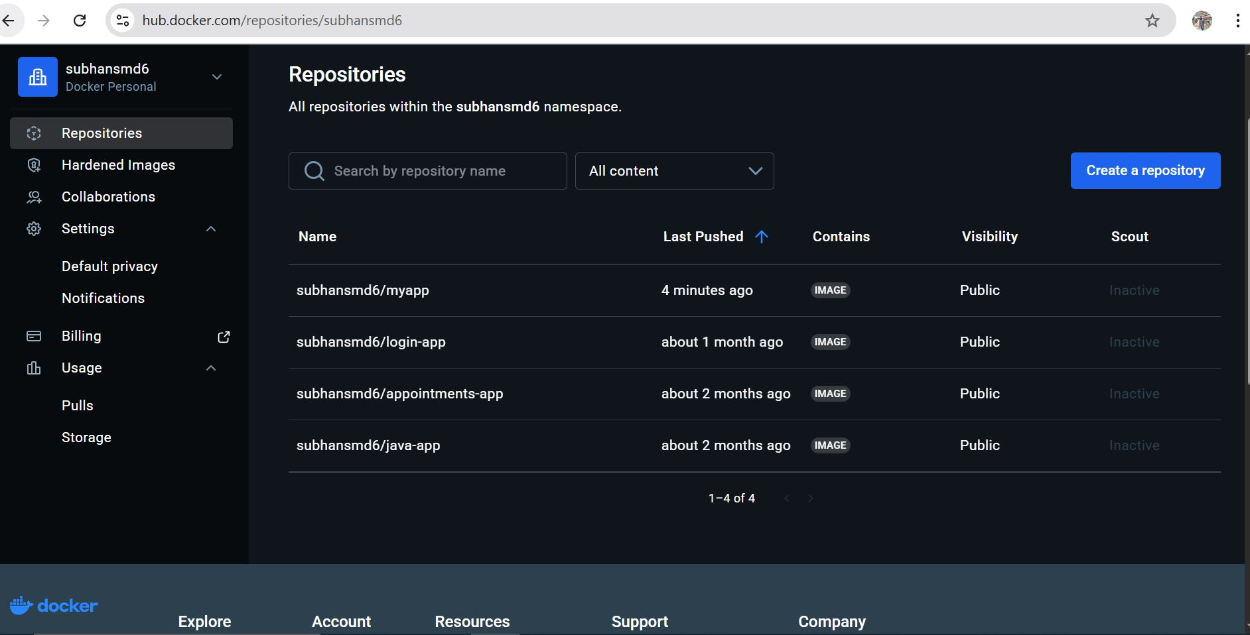

Step 7: Final Validation
Explain: - End-to-end pipeline success - CI/CD automation achieved
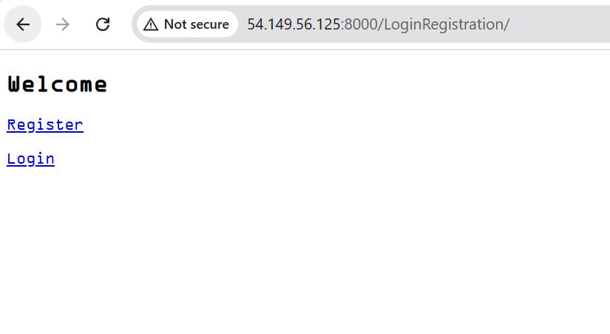

7. CI/CD Pipeline Design (Jenkins)

7.1 Pipeline Stages
- Source Code Checkout
- Maven Build
- SonarQube Code Analysis
- Artifact Upload to Nexus
- Docker Image Build
- Push Docker Image to DockerHub

7.2 Jenkins Configuration
- Required plugins installed via automation
- Global tools configured (JDK, Maven)
- Credentials stored securely in Jenkins Credentials Manager

8. SonarQube Integration
- SonarQube runs as a Docker container
- Jenkins connects via Sonar token
- Maven Sonar plugin used for analysis
- Ensures static code quality checks before proceeding

9. Nexus Integration
- Nexus runs as a Docker container
- Maven artifacts pushed to Nexus
- Acts as a centralized artifact repository

10. Docker & Image Management
- Docker installed on a dedicated host
- Jenkins builds Docker images remotely
- Images pushed to DockerHub
- Enables container-based deployment

11. Security Considerations
- SSH key-based authentication
- Jenkins credentials abstraction
- No hardcoded secrets in code or playbooks
- Network access restricted using security groups

12. Challenges Faced & Solutions
Challenge | Resolution
Jenkins plugin installation failures | Used compatible plugin versions
SonarQube access issues | Fixed container port & security groups
Terraform state changes | Analyzed and corrected configuration drift
Maven-Sonar integration errors | Proper plugin and tool configuration

13. Outcomes & Benefits
- Fully automated CI/CD pipeline
- Reduced manual intervention
- Production-like DevOps setup
- Interview-ready, real-world project

14. Future Enhancements
- Jenkins distributed agents
- Kubernetes / EKS deployment
- Terraform remote backend
- Monitoring & alerting
- CI/CD notifications

15. Conclusion
This POC successfully demonstrates a real-world DevOps platform using industry-standard tools and best practices. It validates the feasibility of automating the complete software delivery lifecycle with scalability, security, and maintainability in mind.

